Sentinel Bio+
Concept of Operations (ConOps)

San Diego State University (SDSU)
San José State University (SJSU)
San Diego Space Institute
Fall 2025 Preliminary Design Review

Contents
1 Mission Summary 2
2 Deployment Plan 2
3 Mission Lifecycle 2
Mission Operations 2
3.1 Operational Modes 2
3.2 Ground Segment Detail 3
3.3 Mission Operation Organization 4
3.4 Requirements Traceability 4
3.5 Autonomy Behavior Clarification 4
3.6 Radiation and Drag Science Outputs 5
3.7 De-orbit Compliance 5
4 Operations Concept 5
SDSU Payload Operations (Rila and ZES Integration) 6
SDSU Supporting Sensors (Accelerometer and Magnetometer) 6
5 Ground Segment 9
6 Onboard Autonomy 9
7 End-of-Life Operations 9
8 Closing Statement 9

1 Mission Summary
The Sentinel Bio+ mission aims to deploy six 3U CubeSats to monitor radiation levels and drag forces in low Earth orbit (LEO). The primary objective is to gather long-term environmental data that will inform future space weather models, enhance radiation shielding design, and support student-led research in spacecraft operations.

Each CubeSat will include the following payloads:
- RILA radiation dosimeter
- ZES radiation monitoring board
- Magnetometer and accelerometer

Orbital Rationale:
The Sentinel Bio+ constellation utilizes three distinct orbital inclinations (90°, 60°, and 40°) to sample varying radiation and thermospheric drag regimes. This configuration provides several scientific advantages:
- SAA Coverage: The orbits are designed to straddle the South Atlantic Anomaly (SAA), facilitating repeated traversal of the most intense radiation region in low Earth orbit.
- Comparative Analysis: The multi-inclination approach enables the study of radiation exposure and drag effects as a function of geomagnetic latitude and trapped particle populations.
- Temporal Sampling: Multiple planes improve temporal sampling through independent passes without requirement of a single high-cost orbit.
The selected altitudes and inclinations are modeled using NASA’s AE9/AP9 v1.5 environment models to ensure the spacecraft remains within the 95th percentile safety margin during its one-year decay from 550 km to 450 km.

2 Deployment Plan
The constellation will consist of three orbital planes with the following characteristics:
- Altitude: 500 km circular
- Inclinations: 90°, 60°, and 40°
- Launch: Rideshare opportunity (targeting Q2 2027)
- Deployment: P-POD system (CubeSat standard)

2.2 Spacecraft Architecture & Shielding
To ensure payload survivability and data integrity:
- Shielding Requirement: The RILA sensor shall be positioned within the satellite bus to utilize a design baseline of ≥ 2.0 mm Aluminum-equivalent shielding.
- Structural Implementation: This shielding is expected to be achieved through the 1.5 mm chassis supplemented by internal structural components, PCB copper planes, and the RILA instrument housing.
- Modeling Baseline: This 2.0 mm threshold serves as the primary input for the radiation dose estimates provided in Appendix B.

3 Mission Lifecycle
The mission will follow NASA’s standard lifecycle phases with these scheduled milestones:
- Phase 0 – Concept Exploration: Initial planning and idea formation.
- Phase A – Concept Development: Finalize ConOps, stakeholder needs, and early trade studies.
- Phase B – Preliminary Design: Produce block diagrams, requirements documents, and subsystem budgets.
  - Milestone: Preliminary Design Review (PDR) – December 2025
- Phase C – Detailed Design: Complete full CAD, interface definitions, and begin procurement.
- Milestone: Critical Design Review (CDR) – April 2026
- Phase D – Integration and Test: Build, test, and validate satellite units (TVAC, vibe, EMI/EMC).
  - Milestone: Pre-Ship Review – December 2026
- Phase E – Operations: Launch, commissioning, and routine data collection.
- Milestones:
  - Launch: Q2 2027
  - Early Orbit Operations: Q3 2027
  - Science Operations Start: Late Q3 2027
- Phase F – Closeout: Deorbit procedures, data archive, and final reporting.

Mission Operations

3.1 Operational Modes
- Launch and Early Phase (LEOP): Initial detumble, GPS fix, and deploy solar panels.
- Commissioning Mode: Verify all bus components and calibrate the RILA/ZES payload.
- Nominal Operations: Autonomous, routine science data collection and low-latency DTN communication.
- Communications Mode: High-speed S-band downlink of data and uplink of commands.
- Safe Mode (Fault detection and recovery): Preserve Satellite health and power during critical situations.
- Deorbit Mode: Terminate mission and deploy passive deorbit device.

- Exit Authority: Authority to exit Safe Mode resides solely with ground operations, specifically the SDSI Mission Director or designated Flight Director, following a formal review of fault context and health telemetry.
- Autonomous Exit: The satellite may autonomously exit Safe Mode only for explicitly defined benign triggers (e.g., transient watchdog resets) and only when all exit criteria are met continuously for a prescribed duration.
- Default State: In all other fault scenarios, the satellite remains in Safe Mode awaiting a direct ground command.

3.2 Ground Segment Detail
- Expected daily pass durations
- Orbital Altitude: 500 km
- Typical Pass Duration: 6 to 10 minutes
- Daily pass Frequency: 2 to 4 passes per day
- Required Latency Goal: Data available to researchers within 24 hours of collection.
- Downlink budget vs. science data volume
- Data generated: 0.6MB/day/satellite x 6 satellites = 3.6MB/day total
- Required Downlink Time: Should be the anticipated S-band data rate.
- The downlink budget is satisfied
- End-to-end data flow from satellite to cloud storage

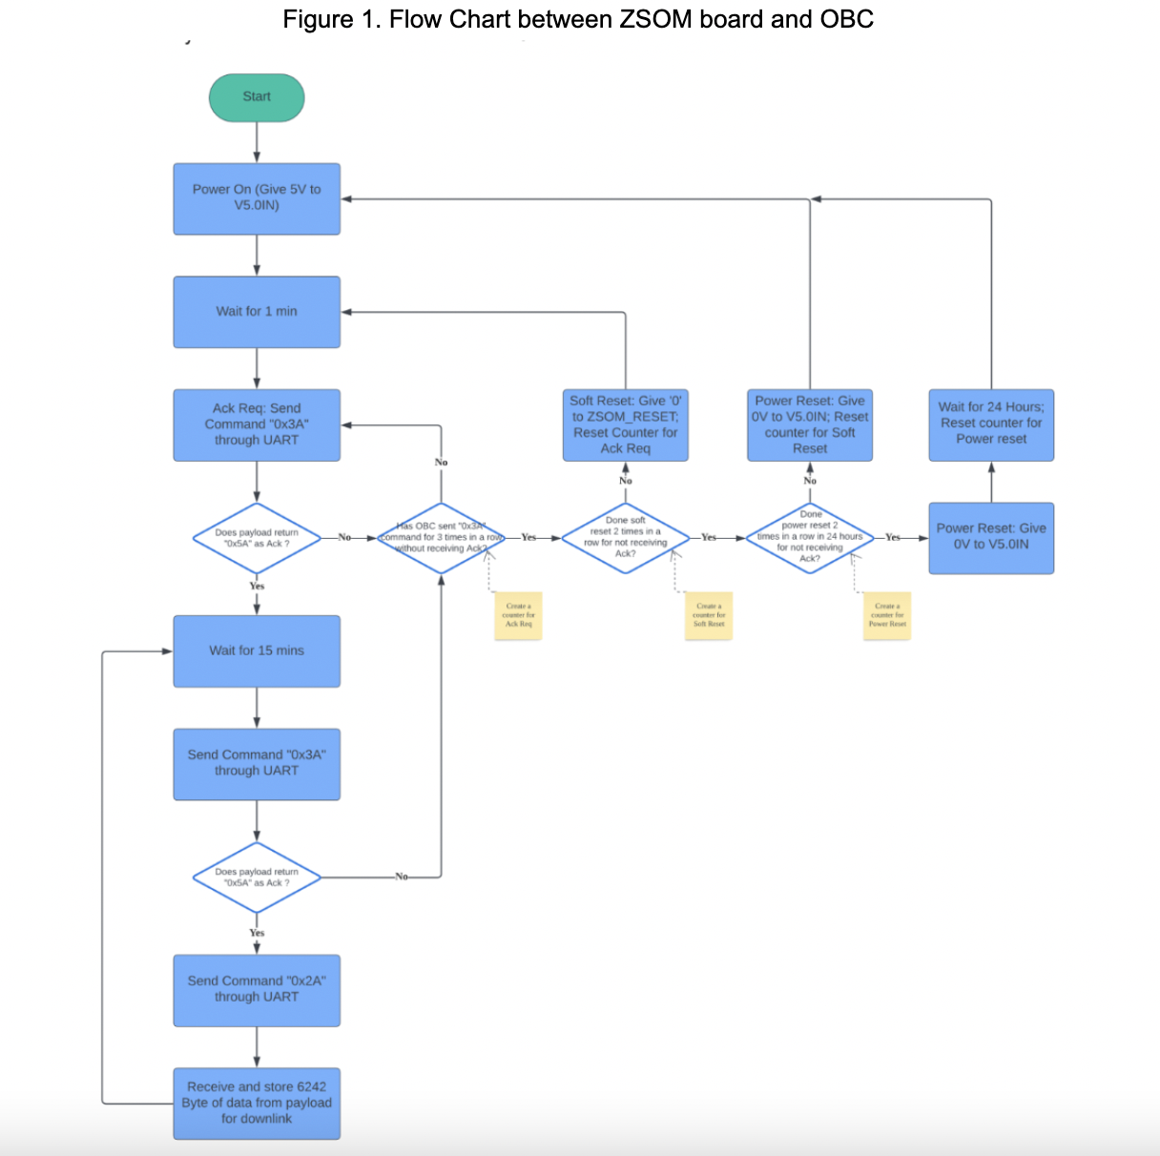
Extended Outage Logic:
The spacecraft is programmed to maintain data integrity and system health during periods of extended S-band unavailability:
- Nominal Collection during Outages: The spacecraft continues standard payload data collection as long as power and thermal margins remain within safe limits, storing all data in onboard memory.
- Priority-Based Data Retention: If onboard storage approaches predefined thresholds, the flight software is configured to selectively retain high-priority event data while automatically discarding the oldest or lowest-priority background data.
- Data-Preservation Posture: In the event an outage threatens critical power, thermal, or storage margins, the spacecraft transitions to a “data-preservation posture”.
- Operational Reduction: While in this posture, the spacecraft reduces its payload duty cycle and defers all nonessential activities until communications are restored and ground commands are received.

3.3 Mission Operation Organization
- Mission Director: Core project management team
- Payload Operations Lead: SDSU Payload Integration team
- Flight Software Lead: SJSU team
- Ground Systems Lead: SJSU team

3.4 Requirements Traceability
RTM Example ID | Description (From RTM) | ConOps Section Satisfying Requirement | Verification Method (from RTM)
PD-002 | The payload shall survive non-operation within -20 °C to +40 °C. | 3.1 Operational Modes (LEOP) | Thermal Test (T): LEOP mode is designed to minimize power and keep the payload off until stable thermal conditions are met.
PD-006 | The ZES board shall forward payload data to the OBC via UART serial communication. | 3.1 Nominal Operations | Functional Test (F): Nominal mode is defined to execute the RILA →ZES→OBC data path.
PD-011 | The payload shall survive non-operation during LEOP for NASA G-levels > 2 years. | 3.1 Operational Modes (LEOP) | Inspection (I): The LEOP mode ensures the payload remains passively stowed until the mission is ready to transition to commissioning.
PD-023 | The RILA/ZES shall demonstrate a TTL ON/OFF enable to control RILA power. | 3.5 Autonomy Clarification | Function Test (F): The safe mode logic immediately commands RILA power OFF via the TTL interface.

3.5 Autonomy Behavior Clarification
- Fault triggers (Low Voltage, Over-Temperature, Software Error)
- Battery State of Charge drops below 30% for more than 5 consecutive minutes.
- A critical bus component (OBC or battery) temperature exceeds 45 °C.
- Watchdog timer reset occurs 3 times within 60 minutes.
- Prioritized data handling during solar events:
- The ZES board flags the collected data packets with a critical priority tag before sending them to the OBC storage.
- The OBC moves all priority data to the front of the downlink queue, ensuring it is the first data transmitted during the next S-band pass.
- Safe-mode power and sampling reductions:
- In safe mode, the minimum systems needed for survival are active. All payloads and the S-band transmitter are OFF.
- Sampling reductions: The system switches to survival telemetry mode. Health checks (voltage, current, temperature) are reduced from 1 Hz to 1/60 Hz per minute.
- The RILA/ZES polling is completely halted.

- Handshake & Fault Recovery:
- The OBC polls the ZES payload via UART using command 0x3A. A 0x5A acknowledgement confirms the successful data acquisition. If the acknowledgement is not received, the OBC executes a tiered recovery: first, a soft reset is initiated via the ZSOM_RESET pin; if the failure persists, a Power Cycle of the 5V rail is performed to clear latch-ups.

- Threshold Configurability:
To allow for on-orbit tuning, autonomy thresholds are designed as flexible parameters:
- Uploadable Parameters: Thresholds for battery state-of-charge, temperature limits, and reset counters are implemented as uploadable configuration parameters stored in non-volatile memory.
- Version Control: All parameters are version-controlled to support restoration to a known-safe baseline.
- Hard Protections: A limited subset of hard safety protections (e.g., absolute hardware limits) remain non-editable to prevent the execution of unsafe commands.

3.6 Radiation and Drag Science Outputs
- How drag will be computed using accelerometer readings:
- The accelerometer measures the total resistance the satellite experiences. The software strips away other forces to determine how hard the residual atmosphere is pushing. The push is directly converted into the density of the atmosphere at that specific point in space. From getting the atmospheric density, we can compute the drag.
- Role of the magnetometer in attitude or environment interpretation:
- The magnetometer is used by the attitude determination system to calculate the spacecraft's orientation.
- Expected science data products:
- Dose Rate Profiles: Generated by the RILA dosimeter and ZES board. Provides high-resolution, long-term measurements of the ionizing radiation environment
- Atmospheric Density/Drag Estimates: Generated by the accelerometer, it provides highly accurate, short-term measurements of residual atmospheric density. The data is crucial for enhancing future LEO orbital prediction models.
Mission Success Criteria:
Quantitative success for the Sentinel Bio+ mission is defined by the following metrics:
- Science Delivery: The spacecraft must deliver validated radiation dose-rate and drag proxy measurements for nominally ≥ 70-80% of planned mission days.
- Data Quality: Success requires the inclusion of sufficient metadata, such as time tags and ephemeris, to support cross-satellite comparisons.
- Program Success: Final mission success is demonstrated through the archival and release of the dataset, including at least one comparative analysis across the different orbital inclinations.

Success is measured against the modeled Total Ionizing Dose (TID) baseline established in Appendix B, allowing for real-time validation of the AE9/AP9 environment models.

3.7 De-orbit Compliance
- Projected deorbit time at 500km:
- Natural decay: The projected deorbit time without the device is 15 to 20 years. This shows that the initial orbit is low enough to be compliant with the NASA/DoD orbital debris mitigation requirements.
- Assisted decay: The projected decay time with the device is less than 5 years.
- Exo-Brake deployment timing:
- The deployment will be commanded at the end of life. A ground command triggers this after the final data pass and closure of the mission science phase.
- Automatically deploys by the flight software if the satellite is unresponsive or the 25-year clock approaches.
- Compliance with the 25-year NASA/DoD orbital debris mitigation requirement

4 Operations Concept
Each satellite autonomously collects environmental data and transmits it during scheduled S-band ground station passes. A cognitive scheduler onboard prioritizes data queues for trans missions, optimizing based on time, orbit location, and system health.

Key operational parameters:
- Polling interval: 15 minutes per satellite
- Data volume: 0.6 MB/day/satellite
- Primary comms: S-band for science data
- Backup comms: UHF for telemetry; Iridium (optional) for emergency operations

SDSU Payload Operations (Rila and ZES Integration)
The SDSU payload subsystem consists of the Rila radiation dosimeter and the ZES ZSOM-M01 board, which together form the radiation monitoring payload for Sentinel Bio+.

The Rila dosimeter measures the ionizing radiation environment in Low Earth Orbit (LEO) and outputs digital spectra data through an RS-422 differential serial interface. The ZES board serves as a middleware microcontroller that:
- Receives Rila data via RS-422.
- Processes and reformats the telemetry into standardized packets.
- Forwards data to the Onboard Computer (OBC) using a UART serial connection for storage and downlink scheduling.

Payload operations are governed by the following parameters:
- Power Input: Rila operates at 12 V DC ± 0.5 V, while ZES runs on 5 V regulated power.
- Polling Frequency: The ZES board collects and logs Rila data approximately every 15 minutes.
- Data Volume: Average data packet size is 6–7 kB per collection cycle.
- Temperature Range: Payload components operate nominally between −20 °C and +40 °C.
- Watchdog & Reliability: ZES includes built-in Single-Event Upset (SEU) protection and latch-up detection to ensure continuous operation in the radiation environment.

During integration testing, the Rila–ZES communication will first be validated through the Rila simulator provided by SRTI in early 2026. Once verified, the system will undergo environmental testing (thermal-vacuum, EMI/EMC, vibration) prior to flight qualification.

SDSU Supporting Sensors (Accelerometer and Magnetometer)
The SDSU supporting sensors consist of the LIS3DH accelerometer from STMicroelectronics and the LIS2MDL magnetometer from STMicroelectronics. The sensors will provide critical orientation and positioning features for the duration of the mission.

Primary Accelerometer: MS1002-class
- Power Input: Operates at a regulated 3.3V DC power rail.
- Detection Capabilities: High-stability 3-axis sensing of µG-level (micro-gravity) acceleration.
- Output Rates: 200 Hz - 800 Hz
- Temperature Range: -40 °C to +125 °C and a storage range of -55 °C to +125 °C.
Secondary Accelerometer: ADXL355-class MEMS
- Power Input: Operates at 2.25V to 3.6V
- Detection Capabilities: 3-Axis Sensing
- Output Rates: 800 Hz
- Temperature Range: -40C to +125C
LIS3DH magnetometer: Awaiting Information
The corresponding sensors will be validated through bus integration testing and physical demonstrations, and set up to ensure proper sensing data is acquired.
Operational Mode Table and State Diagram: Haven't been given enough information.
Downlink Budget
- The mission requires less than 30 seconds of total dedicated S-band transmission time per day to downlink the 3.6 MB of science data.

Student and Faculty Mission Operation Roles
Required Functional Role | Student Team Responsibility | Role | Key Operational Focus
Mission Director Function | Core Project Management Team | Provides final approval on critical decisions | Overall mission integrity, risk management, and final authority on nominal vs. contingency operations.
Payload Operations Lead | SDSU Payload Integration Team | Provides technical guidance on science data validation | Ensuring data acquisition quality, payload health, and managing the science data pipeline.
Flight Software Lead | SJSU Team | Oversees the implementation of autonomy and safety logic | Maintaining the onboard autonomy, implementing safing logic, managing flight code updates, and commanding mode transitions.
Ground Systems Team | SJSU Team | Approves ground segment and budget compliance | Scheduling all S-band ground station contacts, managing the downlink budget, and coordinating the backup UHF network.

Science Objectives and data products descriptions
- Radiation Environment Monitoring:
- Goal: To measure the amount of harmful ionizing radiation in LEO.
- Data product: Dose rate profiles that show where and how quickly the radiation builds up along the satellite's orbit.
- Impact: This data is vital for validating radiation models and designing better shielding for future satellites and human missions.
- Atmospheric Drag and Density Sensing:
- Goal: To measure how much resistance the satellite encounters from the thin atmosphere.
- Data Product: Atmospheric Density Estimates.
- Impact: This data improves models used to predict satellite orbits and track space debris more accurately.
Fault Management and Autonomous Behaviors
Fault Category | Trigger Condition | Autonomous Response
Power Fault | Battery SoC below 30% for 5 minutes | Transition to safe mode (Mode 4): Power OFF all payloads; activate minimal UHF telemetry beacon.
Thermal Fault | OBC or Battery temperature exceeds +45 °C | Thermal Safing Rotation: Command ADCS to sun-avoidance orientation; Power OFF non-essential components.
Software Fault | Flight Software watchdog timer resets 3 times in 60 minutes | System Reset & State Reload: Initiate hard OBC reset; revert to last known good configuration from flash memory.

RTM Example ID | Requirement Description | ConOps Section Satisfying Requirement | Verification Method
PD-004 | The ZES board shall use 5V $±$ 0.25V during nominal operation. | 3.5 Safing Logic | Functional Test (F) / Power Test (P)
PD-006 | The ZES board shall forward payload data to OBC using UART serial communication | 4.0 Operation Concept | Functional Test (F)
PD-011 | The payload shall survive non-operation during LEOP | 3.1 Operational Modes (LEOP) | Inspection (I)

5 Ground Segment
- Primary Ground Station: Atlas Space Operations (S-band)
- Backup Network: UHF amateur radio ground stations
- Cloud Processing: AWS Ground Station as a Service (GSaaS)

6 Onboard Autonomy
Sentinel Bio+ will adapt technologies demonstrated in TechEdSat-11, including:
- Delay/Disruption-Tolerant Networking (DTN)
- Health monitoring and safing logic
- Priority-based data queuing

7 End-of-Life Operations
To meet orbital debris mitigation standards, satellites will:
- Deploy Exo-Brake or similar passive deorbit device
- Perform final data pass
- Enter safe mode and shutdown

8 Closing Statement
”Define the right system, then design the system right.” — NASA Systems Engineering Handbook

Appendix A: Radiation Modeling Methodology
- Environment Models: NASA AE9/AP9 v1.5 (Standard Flux Model)
- Shielding Baseline: The radiation analysis assumes a total hemispherical shielding of ≥ 2.0 mm Aluminum-equivalent.
- Reference Material: For the purpose of the Total Ionizing Dose (TID) calculation, 6061-T6 Aluminum is used as the reference shielding material.
- Implementation: This 2.0 mm equivalent is achieved through the 1.5 mm primary aluminum chassis supplemented by internal structural components, PCB copper planes, and the RILA instrument housing mass.
- Orbital Decay Profile: Modeling is based on a one-year mission duration decaying from an initial 550 km circular orbit down to 450 km.
- Statistical Margin: All results are reported at the 95th percentile (Mean) to ensure conservative engineering safety margins.

Appendix B: Total Ionizing Dose (TID) Estimates

Based on the 2.0 mm Al-equivalent shielding requirements, the following table provides the modeled radiation dose snapshots for the mission.

Table 1: One-year Total Ionizing Dose (TID) per Satellite
Orbit Segment (1 Year) | Shielding at RILA (Al-eq.) | AE9 Dose (e⁻) | AP9 Dose (p⁺) | Total TID (AE9 + AP9) (krad)
Segment 1: 550 km (Start)
Segment 2: 525 km
Segment 3: 500 km
Segment 4: 475 km
Segment 5: 450 km
1-Year Total (Sum of Segments) | (Same Shielding as assumption) | krad(Si) | krad(Si) | krad(Si)

